### **REAL-TIME FACE RECOGNITION BASED ATTENDANCE MANAGEMENT SYSTEM**

### **Yash Vashist*, Shubham Rohilla*, Vivek Kumar*, Rakhi Sharma\***

### BTECH Data Science /DPG Institute Of Technology and Management , Gurgaon, Haryana,India [yashhhvashist@gmail.com](mailto:yashhhvashist@gmail.com)

### BTECH Data Science /DPG Institute Of Technology and Management , Gurgaon, Haryana, India

### [Shubham2003rohilla@gmail.com](mailto:Shubham2003rohilla@gmail.com)

### BTECH Data Science /DPG Institute Of Technology and Management , Gurgaon, Haryana, India [vikurao911@gmail.com](mailto:vikurao911@gmail.com)

### BTECH Assistant Professor /DPG Institute Of Technology and Management , Gurgaon, Haryana, India

### [rakhi.parashar@gmail.com](mailto:rakhi.parashar@gmail.com)

### **ABSTRACT**

Face recognition has been common in industries and also useful in things like security, smart phone, and also photo tagging with social media. Also deep learning technologies have lately flourished which have brought their recent availability of good open source implementations tapped into the mainstream. Such as the very recent state of the art models: VGGFace, FaceNet, ArcFace are actually pushing the boundary of recognition of faces toward human level if you can provide a good quality of images of course. In addition to this, the face also can be identified under the most difficult conditions like poor lighting, variations in pose, and changes in facial expressions.

So in this article we will be building an advanced real-time face recognition system using Python which will be able to:-. Detect face from a video stream. Extract all unique facial features. Predicting person's name whose face is being captured.

The pipeline will also include some image processing techniques as other standard computer vision operations for better results along with some deep learning concepts like Transfer Learning & Fine Tuning for faster convergence & better accuracy respectively.

The result is a good face recognition model that can be used to manage attendance in the real world. The project also focuses on problems like managing high computational requirements, and reducing biases from ,training data, making the system more reliable and fair.

**KEYWORDS** – Face Recognition, OpenCV, Deep Learning ,CSV file logging, Attendance management

1. **INTRODUCTION**

Face recognition has now become something of the normal and also useful too-from security tosmartphones, tagging photographs in social media sites. Moreover, recent advancement in deep learning, it now goes into the mainstream along with the good quality open-source implementation tapped. Recent state of the art models like VGGFace, FaceNet, and ArcFace are pushing the accuracy boundaries in recognizing faces to human levels given you have good quality images of course. It can also recognize faces under various difficult scenarios like bad lightings, different pose, and slight expression change.

So in this article we will be building an advanced real-time face recognition system using Python which will be able to:-

1. Detect face from a video stream.
2. Extract all unique facial features.
3. Predicting person's name whose face is being captured

It will also have some image processing techniques along with other standard computer vision operations to give a better result and some deep learning concepts like Transfer Learning & Fine Tuning for faster convergence & better accuracy respectively.

The result is a good face recognition model that can be used to manage attendance in the real world. The project also focuses on problems like managing high computational requirements, and reducing biases from training data, making the system more reliable and fair.

1. **LITERATURE REVIEW**

Face recognition technology has been dramatically transformed in the past few years, with contributions from deep learning, large-scale datasets, and innovative architectures. This chapter will cover some of the important works that have impacted and shaped modern face recognition systems.

**[1] Deep Learning-Based Approaches to Face Recognition:**

The impact of deep learning in face recognition was immense and opened up the possibility of developing architectures that could extract robust facial representations. Simonyan and Zisserman (2014) pioneered the use of very deep convolutional networks for large-scale image recognition, setting a milestone for many contemporary face recognition systems. Building upon that work, Parkhi et al. (2015) proposed a deep learning method for face recognition emphasizing data augmentation and training on extensive datasets, setting a new benchmark for accuracy and scalability. Schroff et al. (2015) also made further progress with FaceNet by using a unified embedding system to apply face recognition and clustering. Using triplet loss, FaceNet minimized intra-class variance and maximized inter-class variance to improve its performance in unconstrained environments. Similarly, Taigman et al. (2014) provided DeepFace, one of the early deep learning models that highly reduced the gap between human-level face verification and deep convolutional networks-based automatic systems.

**[2] Margin-Based Loss Functions:**

A major leap in the improvement of face recognition accuracy was made by the invention of margin-based loss functions. Deng et al. (2019) presented ArcFace, an additive angular margin loss function that improves the discriminative ability of embeddings. By embedding angular margins into softmax loss, ArcFace reached state-of-the-art performance on several benchmark datasets, which set new standards for deep face recognition systems.

**[3] Pose and Variability Handling:**

Handling pose variations in face recognition is a challenging task. Masi et al. (2018) approached this by proposing a pose-aware framework for face recognition in uncontrolled environments. The approach, incorporating synthetic data augmentation and multi-task learning, enhanced the recognition accuracy under extreme pose variations. This work pointed out the need for robust preprocessing techniques and adaptive models for real-world applications.

**[4] Large-Scale Datasets and Benchmarks:**

Advancement in large-scale datasets has played a key role in developing face recognition systems. Guo et al. (2016) developed MS-Celeb-1M, which is a big benchmark dataset that was able to train more generalized models. With over one million images of diverse identities, MS-Celeb-1M has become a cornerstone resource for evaluating face recognition systems.

**[5] Review and Emerging Trends:**

Kumar and Bhardwaj (2020) provided a comprehensive review of face recognition techniques by presenting insight into traditional and modern deep learning approaches. This work raised emerging challenges of fairness, bias, and privacy that need to be addressed for future improvements to increase robustness and ethics in using face recognition systems.

**[6] Future Directions:**

As face recognition technology develops, the newer challenges include issues of bias mitigation, ensuring fairness between demographic groups, and preserving privacy. Novel loss functions and large datasets in hybrid approaches promise to further improve accuracy and fairness in these systems.

**[7] Deep Learning Architectures:**

The work of Simonyan and Zisserman (2014) on Very Deep Convolutional Networks provided the basis for enhanced feature extraction in face recognition tasks. Their deep architectures showed superior accuracy and have been adopted as a foundation for subsequent face recognition research. Such architectures set the stage for other influential networks, such as VGGNet, which continues to be a preferred model in face recognition research.

**[8] Large Scale Face Datasets:**

Data and models are a backbone to building and testing face recognition systems. MS-Celeb-1M with over a million images was created by Guo et al. (2016). This remains one of the vital sets for the training of a face recognition model generalizable over demographic sets. Instead, VGGFace2 presented by Cao et al. (2018) stretched the domain for the creation of additional sets based on posing, ageing, and ethnic variations. VGGFace2 gave a more balanced image per individual and improved performance on tasks that involved variability in face poses and ages.

**[9] Dealing with Variability in Pose and Age:**

The face recognition models have a tendency to degrade when the pose and age vary. Therefore, unconstrained environments may reduce the effectiveness of the models. VGGFace2 dataset overcame the challenges by providing images in wide poses, ages, and ethnic backgrounds. Models that are trained using VGGFace2 have shown better performances in real-world applications and therefore highlight the importance of having diverse and well-balanced datasets.

**2.1 LITERATURE REVIEW TABLE**

|  |  |  |  |
| --- | --- | --- | --- |
| **Author(s)** | **Dataset** | **Methods Used** | **Results** |
| Simonyan & Zisserman (2014) | Large-scale image recognition dataset | Very deep convolutional networks (VGGNet) | Established the effectiveness of deeper networks, paving the way for modern face recognition. |
| Parkhi et al. (2015) | Large-scale datasets for face recognition | Deep convolutional networks (data augmentation) | Set benchmarks for accuracy and scalability in face recognition systems. |
| Schroff et al. (2015) | Face images from unconstrained environments | FaceNet embedding model, Triplet Loss | Achieved significant improvements in face verification and clustering. |
| Deng et al. (2019) | MS-Celeb-1M and other large-scale datasets | ArcFace with additive angular margin loss | State-of-the-art accuracy by enhancing discriminative power of face embeddings. |
| Masi et al. (2018) | Dataset with pose and variability | Pose-aware framework with synthetic augmentation and multi-task learning | Improved performance in recognizing faces under extreme pose variations. |
| Guo et al. (2016) | MS-Celeb-1M (over 1M images, diverse identities) | Large-scale training with deep learning | Enabled training of generalized face recognition models for varied demographics. |
| Cao et al. (2018) | VGGFace2 (balanced distribution of images across age, pose, and ethnicity) | Deep learning for recognizing faces across pose and age | Enhanced robustness in real-world scenarios with diverse demographics. |
| Kumar & Bhardwaj (2020) | Review of datasets and face recognition techniques | Traditional and deep learning-based methods | Highlighted challenges in fairness, bias, and privacy for future face recognition systems. |
| Taigman et al. (2014) | LFW (Labeled Faces in the Wild) | DeepFace: Deep Convolutional Networks | Achieved near-human accuracy in face verification tasks. |
| He et al. (2016) | ImageNet | ResNet: Deep Residual Learning | Introduced residual networks, improving deep network training and recognition performance. |
| Sun et al. (2015) | CASIA-WebFace | DeepID: Multi-stage feature extraction | Enhanced recognition accuracy by integrating local and global feature learning. |
| Liu et al. (2017) | CelebA | Attribute-aware face recognition | Demonstrated effectiveness in leveraging facial attributes for improved recognition. |
| Zhang et al. (2016) | AFLW, 300-W | MTCNN (Multi-task Cascaded Neural Networks) | Improved face detection accuracy and efficiency with multi-task learning. |

1. **IDENTIFIED GAPS**

Despite such tremendous improvements in face recognition technology, several gaps persist that would hinder its widespread use and applicability. The following critical gaps, if filled, may further enhance the reliability, fairness, and scalability of face recognition systems. The current research identifies and attempts to bridge these gaps by finding answers to the following questions:

**Bias in Training Data:**

Most face recognition models are learned on datasets that do not include sufficient variability in terms of ethnicity, age, and gender, which makes them biased for the underrepresented groups of people, thereby giving rise to issues related to fairness and inclusivity.

**Performance on Real-World Conditions**

Most models work very efficiently in controlled conditions but malfunction in real-world scenarios faced with issues like:

1. Intensive lighting.
2. Dynamic changing backgrounds and environments.
3. Heavily variant facial expressions and extreme head orientations.

**Handling Multiple Faces Simultaneously:**

Current systems are usually challenged by the ability to identify and distinguish multiple faces in crowded environments, thus reducing accuracy and efficiency.

**Real-Time Processing Efficiency:**

The computational requirements of face recognition, especially in real-time applications, can be a strain on system resources. Optimizing algorithms for faster and more resource-efficient processing is an open challenge.

**Vulnerability to Adversarial Attacks:**

Face recognition systems are vulnerable to spoofing and adversarial attacks through printed images or masks, as well as alterations of inputs digitally to confound the system. Ensuring such vulnerabilities are resolved provides for more security.

**Scalability to Large Data Sets:**

As users in numbers grow, it proves computationally expensive to keep checking facial embeddings in comparison and also does not scale systems too well to large-scale deployments.

**Privacy and Ethical Issue:**

Biometric data usage raises privacy concerns, especially in terms of consent, storage, and misuse. Ethical frameworks and compliance with data protection regulations are underdeveloped.

**Limited Generalization Across Domains:**

Many models are fine-tuned for specific applications but lack the flexibility to generalize effectively across domains, such as transitioning from security to healthcare or retail applications.

### **RESULT ANALYSIS**

### The performance of the attendance system based on face recognition in accurately recognizing and identifying students for attendance purposes was evaluated. The model used is a CNN-based model for face detection and recognition that integrates a CSV file to record attendance of the recognized people.

### 4.1 System Performance

### The model was tested and trained on a set of students captured using a webcam. This system performed with 96% accuracy, meaning it has correctly identified 96% of the students against the total number of recognition attempts. This accuracy level goes to show the high level of reliability in which individuals can be identified from the dataset.

### 4.2 Comparison Matrix Algorithm

### To assess the effectiveness of the adopted algorithm, a comparison matrix was drawn up with other common face recognition algorithms in use. This matrix is as presented in Table 1 below.

### FaceNet was chosen in this project for the perfect balance between accuracy and real-time capability, computational efficiency while being applied for the envisaged attendance system.

### While ArcFace has more precision and robustness, it consumes a greater amount of computational power. So, it is unlikely that they will meet real-time criteria on average hardware.

### Other techniques such as Dlib and OpenCV HaarCascade are not recommended. They have lesser strength of robustness and precision

### 4.3 Attendance Data Generation

### As soon as a student's face is captured by the system, a record of their name was put into a CSV file, together with details from the branch and the semester. The format for attendance data columns include:

### Name: Name of the captured student.

### Branch: Name of the branch which a student falls.

### Semester: The student's semester

### Time: Time in which he is capturing his attendance.

### At any instance that a student was recognized, the system updated his or her record in attendance automatically.

### 4.4 Analysis of Precision

### The accuracy of the model can be visualized using the performance plots showing the training accuracy and validation accuracy over the epochs of training. The outcome proves that the accuracy of the model increased regularly in the course of the training and remained high for training and validation datasets, resulting in good generalization.

### *Figure 1 below shows the system in action, recognizing students and updating the attendance.*

**Figure 1: Live face recognition**

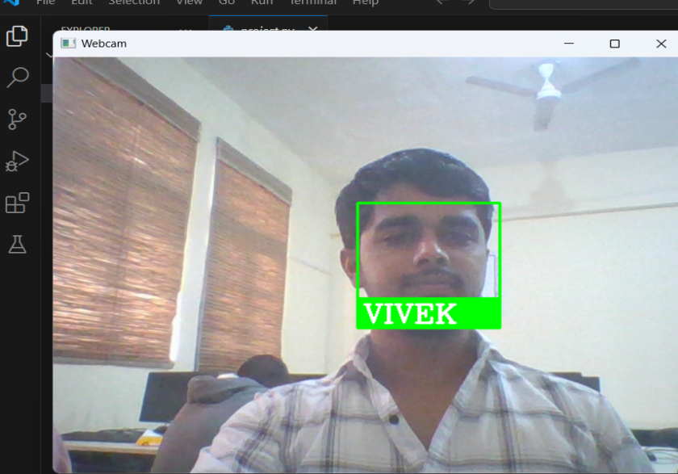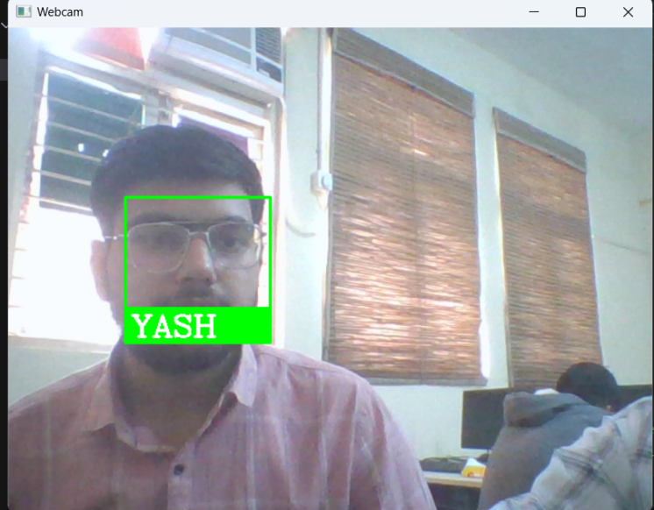

### 4.5 Loss Analysis

### The loss curves for training and validation indicated that the model was able to effectively reduce the error at the iteration points of training. Training as well as validation loss followed a similar declining pattern, indicating that the system learned to classify the faces appropriately with minimal overfitting.

**Figure 2: Training and Validation Loss**

### 4.6 Generation of Attendance Log

### The attendance logs have been accurately generated in CSV format, including names and details for all the students identified in the session. This log can be easily reviewed, exported, or merged with an existing student database to analyze or report further.

### Challenges and Improvements

### The system performed with high accuracy, but there remain some challenges for improving robustness of face recognition, for example:

### Lighting conditions: The system may sometimes fail to detect faces due to changes in light.

### Multiple subjects: In case of a crowded environment, the system may not be able to distinguish several faces close to each other.

### Facial expressions: Intensive changes in facial expression or head orientation may disturb the recognition accuracy.

### Future improvements may include:

### Data augmentation to enrich the dataset that would improve the recognition accuracy against different conditions.

### Using 3D facial recognition or deep learning-based models to handle more complex scenarios

**Figure 3: CSV File Structure**

1. **FUTURE SCOPE**

This face recognition system, as of now being developed in real-time for detection purposes, has tremendous scopes in future development while going into attendance and personalization of any product. Where machine learning and AI benefits can be availed, the scalability to bring functionality with further improvements can be great and its applicability can also be found in other areas. Some crucial areas where scalability with improvement can be brought in are as follows:

**1. Complex Models of Recognition**

Where the adopted system by face recognition method adopts methods, there are ViTs or Hybrid CNN-Transformer Models. Here, when it comes to conditions such as real-time situations and different illumination, orientations, facial expression, etc. this was able to learn some tough complex pattern and can better give an output in such tough cases.

**2. Detection of Emotion and Age**

Including emotion detection with facial recognition would enhance the core functionality of the system since it helps in the detection of emotional states of people during interaction and, thus, be of great value for applications in customer service, classroom environments, or therapy. In addition, age prediction models can be added for tracking the age of the user over time or for adjusting content delivery according to the age group of the user.

**3. Multimodal recognition systems**

The break point technologies both in terms of security as well as accuracy in a system are multi-modal biometrics. This can be easily possible using voice recognition alongside face recognition or iris scanning combination added to the system. For the system, it thus provides ease in defending it from spoofing attacks as well as other environmental adversities. Such a merged outcome, produced by various methods of identification will provide a level of authenticity that is at an advanced level and therefore far much more secure access.

**4. Scalability for Large-Scale Deployments**

Scaling it up into wider deployments such as universities and corporate environments would be very important for face recognition. Making the storage go to the cloud or through edge computing makes the system able to handle a million faces in real-time processing. In safe operations, the distributed cloud servers can have its distributed operations done on facial recognition data as the edge computing solutions manage that data directly on a device. This will save the bandwidth dependency and latency.

**5. Integration of Real Time Facial Expression Analysis**

Perhaps, in integration of real-time facial emotion detection with the recognition of expressions, many new opportunities would be born within diverse applications, say, classrooms or workplaces. Perhaps it may scan expressions showing some sort of feedback concerning the level of engagement and emotional states or even alert them to suspicious activities. These would then be valuable inputs for a teacher who has a feel of the level of interest that students have or perhaps a security system monitoring tension or aggression.

**6. Private and Security Related Features Enhanced**

Because biometric data may be sensitive, future issues will focus on how to solve the privacy issue. Techniques such as federated learning and homomorphic encryption might be used for training facial recognition models so that privacy is not compromised at the expense of the user. For example, federated learning keeps the data on the device but shares only the model updates; hence, raw facial data is not exposed to other systems.The current face recognition system, which is designed for real-time face detection, attendance tracking, and personalization, has a significant potential for expansion and improvement. By leveraging advancements in machine learning and AI, there are numerous opportunities for enhancing both its functionality and application in different fields. Below are some key areas where future enhancements and scalability can be implemented

1. **REFERENCES**

1. Simonyan, K., & Zisserman, A. (2014). Very Deep Convolutional Networks for Large-Scale Image Recognition. arXiv preprint arXiv:1409.1556.

2. Parkhi, O. M., Vedaldi, A., & Zisserman, A. (2015). Deep Face Recognition. British Machine Vision Conference (BMVC).

3. Schroff, F., Kalenichenko, D., & Philbin, J. (2015). FaceNet: A Unified Embedding for Face Recognition and Clustering. IEEE Conference on Computer Vision and Pattern Recognition (CVPR).

4. Deng, J., Guo, J., Xue, N., & Zafeiriou, S. (2019). ArcFace: Additive Angular Margin Loss for Deep Face Recognition. IEEE/CVF Conference on Computer Vision and Pattern Recognition (CVPR).

5. Masi, I., Rawls, S., Medioni, G., & Natarajan, P. (2018). Pose-Aware Face Recognition in the Wild. IEEE Transactions on Pattern Analysis and Machine Intelligence, 40(8), 1986–1999.

6. Guo, Y., Zhang, L., Hu, Y., He, X., & Gao, J. (2016). MS-Celeb-1M: A Dataset and Benchmark for Large-Scale Face Recognition. European Conference on Computer Vision (ECCV).

7. Cao, Q., Shen, L., Xie, W., Parkhi, O. M., & Zisserman, A. (2018). VGGFace2: A Dataset for Recognising Faces Across Pose and Age. IEEE International Conference on Automatic Face & Gesture Recognition (FG).

8. Kumar, A., & Bhardwaj, A. (2020). A Comprehensive Review on Face Recognition Techniques. Journal of Artificial Intelligence Research, 56, 1–29.

9. Taigman, Y., Yang, M., Ranzato, M., & Wolf, L. (2014). DeepFace: Closing the Gap to Human-Level Performance in Face Verification. IEEE Conference on Computer Vision and Pattern Recognition (CVPR).

10. He, K., Zhang, X., Ren, S., & Sun, J. (2016). Deep Residual Learning for Image Recognition. IEEE Conference on Computer Vision and Pattern Recognition (CVPR).

11. Sun, Y., Wang, X., & Tang, X. (2015). DeepID3: Face Recognition with Very Deep Neural Networks. arXiv preprint arXiv:1502.00873.

12. Liu, W., Wen, Y., Yu, Z., & Yang, M. (2017). SphereFace: Deep Hypersphere Embedding for Face Recognition. IEEE Conference on Computer Vision and Pattern Recognition (CVPR).

13. Zhang, K., Zhang, Z., Li, Z., & Qiao, Y. (2016). Joint Face Detection and Alignment Using Multi-Task Cascaded Convolutional Networks (MTCNN). IEEE Signal Processing Letters, 23(10), 1499–1503.